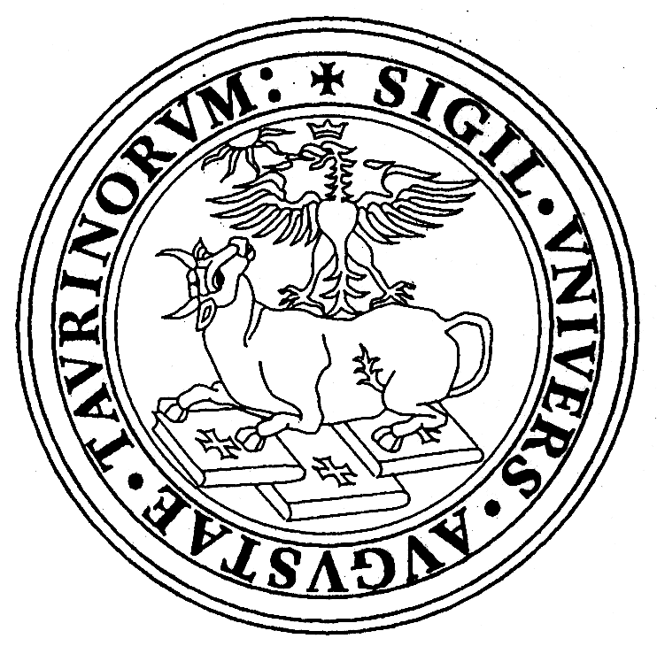 | Università degli Studi di Torino  DIPARTIMENTO di BIOLOGIA ANIMALE e dell’UOMO  Via Accademia Albertina, 13 - 17  10123 TORINO – Italia  Laboratorio di Antropologia Tel +39-011 6704707 -Fax+39-011 6704732

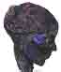
V WORLD CONGRESS ON MUMMY STUDIES
TORINO, ITALY
September 2-5 2004

SECOND NOTICE AND CALL FOR PAPERS

Dear colleagues:

The V World Congress on Mummy Studies is only one year away and we are looking forward to having you with us in Turin. Mummy research has presented new and exciting challenges in the past two years since we met in Greenland and the 2004 meeting will be a wonderful academic opportunity for learning and discussing about new findings and theories.

The World Congress on Mummy Studies encompasses all aspects of research dealing with preserved human and animal bodies, skeletal remains, and cultural issues that are pertinent to the understanding of ancient human biology and funerary practices. Sophisticated new technologies are constantly being applied to these ancient remains in order to develop ways of research that will generate more information while simultaneously helping to preserve the specimens under study. The aim of the Congress is to bring together researchers working in different fields in different countries to exchange information and discuss in-depth the topic of mummified remains. The scope ranges from research problems and limitations with mummified and skeletal remains to conservation and the application of highly sophisticated technology in mummy research, such as DNA analysis and non-invasive 3D computerized imaging.

Your contribution is essential for the success of the World Congress on Mummy Studies. The following sessions will cover a good number of topics: 1. Opening symposium: Italian Mummies; 2. Frozen Mummies, Desert Mummies and Bog Bodies; 3. Paleopathology and Paleoparasitology; 4. Applied Technologies (hair studies, DNA, computerized imaging, paleodiet, etc); 5. Conservation of Mummies and Museums; 6. Mummification Methods and Animal Mummies; 7. Funerary Archaeology; 8. Free Communications; 9. Poster Presentations.

The Free Communications session will be organized by topics according to the papers presented.

Format of presentations and official language
The official language of the Congress is English. There will be NO simultaneous translation. Speakers will have 15 minutes plus 3 minutes for questions. In your Abstract Form, please make sure to indicate the type of visual and/or audiovisual equipment you will require for your presentation. If presenting a video, please indicate if your tape comes in a format different from the European PAL system. Also be advised that video or DVD presentations may require special arrangements. For PowerPoint users it is suggested that photographic images NOT be scanned at high resolution in order to keep downloading times at a minimum.

Abstract Preparation
Abstracts should be organized as follows:
a. Title
b. Name(s) of author(s) (full first and last names). The name of the author presenting the paper at the Congress should be underlined.
c. Indicate with asterisks the institutional affiliation of each author.
d. Five keywords.
e. Abstract not to exceed 150 words, single spaced, Times New Roman font 12 with 2.5cm margins. No references, figures or tables.
f. Required equipment: Slide projectors (1 or 2 side by side); PowerPoint; Transparencies Projector; Video or DVD (PAL or American).
g. Please send in Word format or RTF (Rich Text Format) via e-mail to mummy.congress2004@unito.it or by priority air mail to:

Prof.ssa Emma Rabino Massa
Università di Torino
Dipartimento di Biologia Animale e dell’Uomo
V World Congress on Mummy Studies
Via Accademia Albertina 17
10123 TORINO, ITALIA

Fax: +39 011-6704732

Deadlines for all abstracts, including posters: JULY 15th 2004
All abstracts will be read by the Scientific Committee and printed in two languages in the book of abstracts. The sooner we receive them the faster we will finish our work. Thank you for considering this matter.

Poster size: max 100cm X 70 cm

Registration
Since the time the First Communication was mailed, the exchange rate between US Dollars and the Euro has increased considerably. Due to this situation, the President of the Congress has modified the registration fees as follows:

Until July 31st 2004

North America, Western Europe, Japan, Australia and New Zealand:
Delegate: 250 Euros
Accompanying person: 100 Euros
Students: 50 Euros

All other countries:
Delegate: 110 Euros
Accompanying person: 40 Euros
Students: free
After July 31st 2004

North America, Western Europe, Japan, Australia and New Zealand:
Delegate: 300 Euros
Accompanying person: 150 Euros
Students: 50 Euros

All Other Countries:
Delegate: 150 Euros
Accompanying person: 80 Euros
Students: free

The registration fee covers: Official cocktail, Official Dinner, lunch on Thursday 2, Friday 3 and Saturday 4, all coffee breaks, private guided visit to the Egyptian Museum, private visit to the mummy exhibit at the Anthropological Museum of the University of Turin, delegate kit with Congress materials, and activity program for accompanying persons.

Form of Payment
1. Bank Transfer to: V World Congress on Mummy Studies –
Account number: 1000 / 00003157, San Paolo IMI Filiale :00530 –
Piazza Carlo Emanuele II, 13/A – 10123 Torino –
Coordinate Bancarie for Italy: (Italian Transfers only)
K 01025 01036 100000003157
Coordinate Bancarie for other Countries:(International Transfers only)
IBAN IT79 K010 2501 0361 0000 0003 157
BIC IBSPITTM

2. Cash at time of registration

Travel and Accommodations
There are direct flights to Torino Airport from several European cities such as Madrid, Paris, Frankfurt or Munich. You may also decide to fly to nearby Milan and connect to Torino by train or bus. Please let us know your travel plans in advance so that we may assist you. Torino has hotels for all budgets but reservations are required in advance. We strongly suggest that you make your travel arrangements early. The following is a list of hotels for your convenience:
HOTELS

GRAND HOTEL SITEA**** single 143,00 € double 190,00 €
Via Carlo Alberto 35 breakfast included
tel. + 39 011-5170171 fax. +39 011-548090
WWW.thi.it
e-mail: sitea@thi.it

JOLLY HOTEL LIGURE **** single 137.00 € double 160,00€
Piazza Carlo Felice 85 breakfast included
tel. +39 011-55641 fax. +39 011-535438
www.jollyhotels.it/ita/ALBERGHI_scheda_classic.asp?Obj=1302
torino_ligure@jollyhotels.it

HOTEL CRIMEA*** single 95,00 € double for single occupancy 115,00€ double occupancy 130.00 €
Via Mentana 3 breakfast included
tel. + 39 011-6604700 fax. + 39 011-6604912
http://www.langhe.net/hotelcrimea/default2.htm
hotel.crimea@hotelres.it

HOTEL GRAN MOGOL*** single 62 € double 83 €
Via Guarini 2 breakfast included
tel. +39 011-5612120 fax.+39 011-5623160
http://reservations.turinhotelbookings.com/hotel/10005488-10192122O.html
http://www.accommodation-source.com/hotels/TRN_torino/best_western_hotel_gran_.html

HOTEL DES ARTISTES *** single 85,00 € double for single occupancy 93,00 € double occupancy 115,00 €
Via Principe Amedeo 21 breakfast included
tel. + 39011-8124416 fax. + 39 011-8124466
http://www.desartisteshotel.it/

HOTEL ALPI RESORT*** single 50,00 € double for single occupancy 65,00 € double occupancy 75,00 € triple occupancy 103,00 €
Via Bonafous 5 breakfast included
tel. + 39 011-8129677 fax. + 39 011-8134973

UNIVERSITY CAMPUS HOUSING (1) single 20,00 €
Via Cavour, 32 double 17,00 € per person
Max 50 beds
(1)Since space is limited, we strongly suggest making early reservations. Fifty percent advance payment is required.

N.B. Please complete the attached hotel reservation form and sent it to us as soon as possible
Please be advised that these prices are subject to change.

Program for Accompanying Persons
Torino is a city offering many tourist attractions. It is a typical Northern European city with an elegant architecture and important industrial and commercial centers, but it also preserves the intimacy of every day life in its small bars and street cafes. The beautiful countryside surrounding the city is dotted with small villages and framed by the monumental Alps. Torino and the nearby Alpine Sestriere will host the 2006 Winter Olympics.
Some activities have been planned for those accompanying persons who would like to enjoy all what our city has to offer. The detailed program will be known at the time of registration.

Excursion
The program of the excursion in Bolzano is under preparation.

FURTHER INFORMATION IS AVAILABLE IN OUR WEB PAGE:
http://www.dba.unito.it/seminari/mummy2004.html

