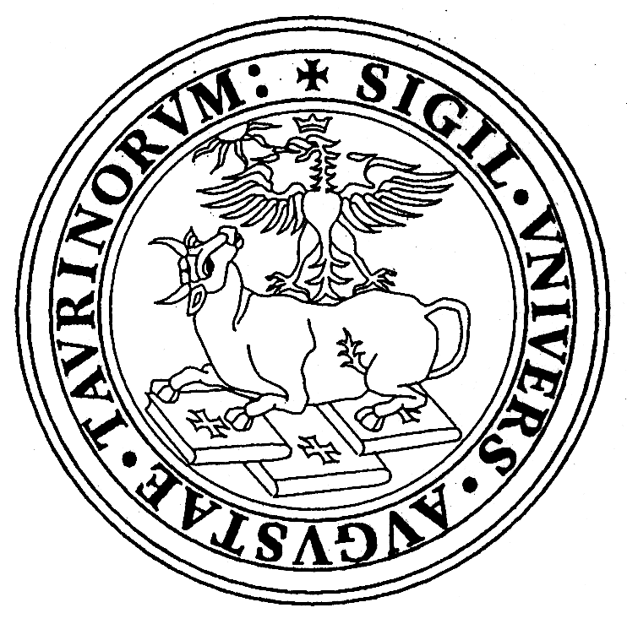 | Università degli Studi di Torino  DIPARTIMENTO di BIOLOGIA ANIMALE e dell’UOMO  Via Accademia Albertina, 13 - 17  10123 TORINO – Italia  Laboratorio di Antropologia Tel +39-011 6704707 -Fax+39-011 6704732
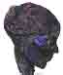

V WORLD CONGRESS ON MUMMY STUDIES

TORINO 2-5 September 2004

We are delighted to send you the first notice regarding the V World Congress on Mummy Studies, to be held in the city of Torino, from 2 to 5 September 2004.

Turin has a long tradition of anthropological studies of ancient populations, particularly Egyptians because of the many collections of mummies and skeletons that have enriched the two main museums of the city through the years, the Museum of Anthropology and the Egyptian Museum.
These collections assume the important role of true biological archives and, in a global description of man, permit the integration of historical data with those from bioanthropological research.
The anthropological collections were assembled by Giovanni Marro during the excavation campaigns of the Italian Archeological Mission in Egypt conducted from 1903 to 1920 by Ernesto Schiaparelli, Director of the Egyptian Museum of Turin, and then from 1930 to 1937 by his successor Giulio Farina. Marro was the only one that combined archeological and anthropological research.
The anthropological egyptian collections now are housed in the Museum of Anthropology and Ethnography of the University and in the Egyptian Museum of Turin; the two museums are linked by an almost one hundred-year collaboration.
The main collection, because of its great scientific value, is the "G. Marro" Egyptian anthropological collection, housed in the Museum of Anthropology. It is fourth in the world in importance and size, but first for the research that has been conducted on its specimens, especially in recent years. In all, it consists of more than 650 complete skeletons and 1300 isolated skulls, most in an excellent state of preservation. To this osseous material are added 80 heads of mummies (some Predynastic), 5 virtually complete Predynastic mummies and 15 Dynastic ones. The material originates mainly from the Dynastic necropolises of Asyut and the Predynastic and Dynastic ones of Gebelein in Upper Egypt; it has been identified and classified chronologically, and ranges from the VI to the XI dynasty.

We trust that this Congress will become an occasion to visit our anthropological collections and also, for those interested in mummies, to reinforce the network already established at the previous meetings.
Finally we hope it will be a very pleasant time spent with friends and colleagues.

The main scientific session of the congress would focus on:

- Mummification Methods
- Mummies of Desert

Mummies of Ice
- Italian Mummies
- Archaeology and Mortuary Rituals

Paleobiology and Paleopathology

Parasitology

Hair in Archaelogy
- Tattoos
- Applied Technologies in Mummies Studies
- Conservation of Mummies
- Mummies of Animals
- Free Communications

You can participate in the following categories:
- Presentation of papers
- Presentation of poster
- Video (only VHS format)
- Attendance

INSCRIPTION COSTS

Until 31st December 2003

North America and Europe:
delegate 300 Euro
accompany person 150 Euro
student 50 Euro

Others countries:
delegate 150 Euro
accompany person 75 Euro
student free

After 31st December 2003

North America and Europe:
delegate 350 Euro
accompany person 200 Euro
student 60 Euro

Others countries:
delegate 175 Euro
accompany person 100 Euro
student free

(The registration fee will provide the delegates with access to: welcome cocktail, all Scientific Session, coffee breaks included in the program, delegate kit and congress materials, visit to Egyptian Museum, visit to the Anthropological Egyptian Collections of the Museum of Anthropology)

Modality of payment will be send in second notice.

If you would like to participate, please send your preliminary registration form by:

ordinary mail to:
Prof.ssa Emma Rabino Massa
Università di Torino
Dipartimento di Biologia Animale e dell’Uomo

V World Congress on Mummy Studies
Via Accademia Albertina 17
10123 TORINO, ITALIA

e-mail to:
mummy.congress2004@unito.it

fax to:
Prof.ssa Emma Rabino Massa

V World Congress on Mummy Studies
+39 011 6704732

Deadlines for preliminary registration: 30th June 2003

We’ll send the second notice in July 2003, also by ordinary mail. Here, you’ll find informations about modality of payment for inscription, Hotel rates and tour opportunities
Cordially yours

President of Organizing Commitee
Emma Rabino Massa

Congress Secretatriat
Rosa Boano
Nicoletta Cerutti
Emanuela Massa Dettoni
Marilena Girotti

V WORLD CONGRESS ON MUMMY STUDIES

Torino 2-5 September 2004

PRELIMINARY REGISTRATION FORM
Return fax or ordinary mail to:

Prof.ssa Emma Rabino Massa

Università di Torino
Dipartimento di Biologia Animale e dell’Uomo
via Accademia Albertina, 17 - 10123 Torino ITALIA
Fax +390116704732

Return e-mail to:
mummy.congress2004@unito.it

Family Name_____________________________________________________________

First name_______________________________________________________________
Title____________________________________________________________________
Institution________________________________________________________________
Address _________________________________________________________________
State/Country_____________________________________________________________
Telephone_______________________________________________________________
Fax_______________________________E-mail ________________________________
I partecipate in: □presentation paper □presentation poster □video □attendance
Main scientific sessions:
□Mummification Methods □Mummies of Desert □Mummies of Ice □Italian Mummies □Archaeology and Mortuari Rituals □Paleobiology and Paleopathology □Parasitology □Hair in Archaelogy □Tattoos □Applied Technologies in Mummies Studies □Mummies of Animals □Conservation of Mummies □Mummies of Animals □Free communications

Deadline for preliminary registration: 30th June 2003
Notices about Torino

Torino, located in North-West Italy in Piedmont region
Inhabitants: 901,473
Surface: Kmq 130.17
Altitude: 239 m / 784 ft

Past and present of the city
Was the capital of the Duchy of Savoy, the Kingdom of Sardinia and then the first capital of Italy, from 1861 to 1864.
Torino oers a circuit of great historical and architectural interest: the Savoy Residences. In addition to the Royal Palace, the official residence of the Savoys until 1865, the circuit includes palaces, residences and castles in the city centre and in the surrounding towns.
First an ancient Roman city, Torino was reborn with Emanuele Filiberto, who in 1563 made it the capital of the Duchy of Savoy. When it was raised to the rank of duchy, it was a town of 20,000 inhabitants. Rapid development soon followed, leading to the founding of the university. In the second half of the 17th century, the architects Vitozzi and Castellamonte defined the urban lay-out, characterised by a very harmonious centre and broad, regular streets. Torino thus became Europe's first mainly Baroque capital. This cohesive fabric was the framework for Guarini and Juvarra's major works.
Its urban appearance is still characterised by the continuity of houses along its streets and the uniform regularity of dierent period buildings. Even after the Baroque period, Torino continued its far-sighted expansion - today we might call it a "holistic vision". This is especially true for the expansions between 1700 and the early 1800s, which respected the image of the old city and repeated it in new districts.
Torino's industrial development began in the second half of the 19th century. Industry was the key feature in the city's development throughout the 20th century.

Today, Torino is a city with a thousand faces: a centre of finance and industry, international trade and a meeting point - but at the same time a city pleasant to live in and one with a unique and unmistakable atmosphere.
Seen from the air, Torino shows all its rationality: straight roads crossing at right angles, long tree-lined avenues, great squares and luminous internal courtyards. But it also reveals the imposing presence of nature: four rivers, the hills, parks and gardens that make it one of the greenest cities in Europe.

Torino is served by an ultra-modern airport: “Alessandro Pertini” (Caselle). It has a capacity of over three million passengers a year. Intercontinental links are provided by “Malpensa 2000”, one of Europe’s largest hubs with its 17 million passengers a year.
Five railway stations, two of them international, guarantee easy access from all of Italy and bordering countries: four pairs of high-speed trains travel between Torino and Paris in little more than five hours.
Six dierent motorways connect Torino to major European cities: Milan in 60 minutes, Genoa in 90, Nice e Geneva in two and half hours, Lyon in three hours and Zurich in four.

To suggestions, news, information about our region see the web sites:
http://www.comune.torino.it/english/
http://www.comune.torino.it/espanol/

